Related to the SR emm6-0025 Duties report.

We found following solution

1. This is not a bug
2. If Euro-mit wants to change the logic as marco said then we have a solution.
3. This is not a bug

In lamination and silt sales invoice Import Duties are coming from the table iinv and iinv.iinvaimpduties field.

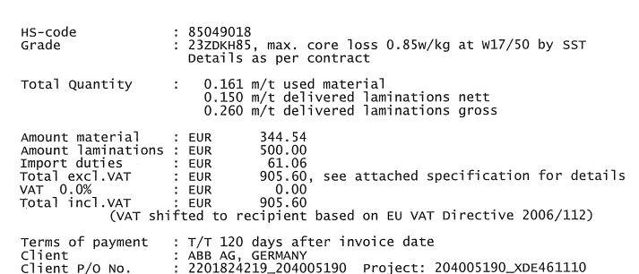

And in the sales report which is ( on the basis of sales invoice number), the NonOpe field is coming from the iinv table and iinv. iinvoice.iinvapayextra / iinvoice.iinvarate

In case of slit 20150898 the iinvoice.iinvapayextra is 0.00 so the iinvoice.iinvapayextra / iinvoice.iinvarate should be 0.00 but lamination iinvoice.iinvapayextra is 61.06 so that NonOpen whould be 61.06.

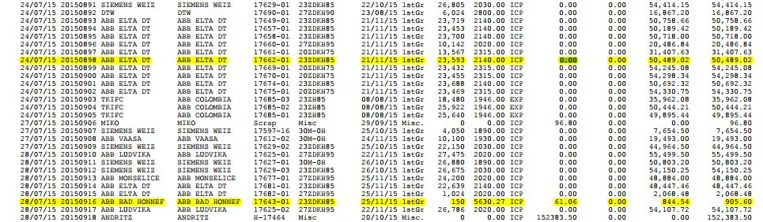

1. If Euro-mit wants to change the logic as marco said, then we have a solution.

